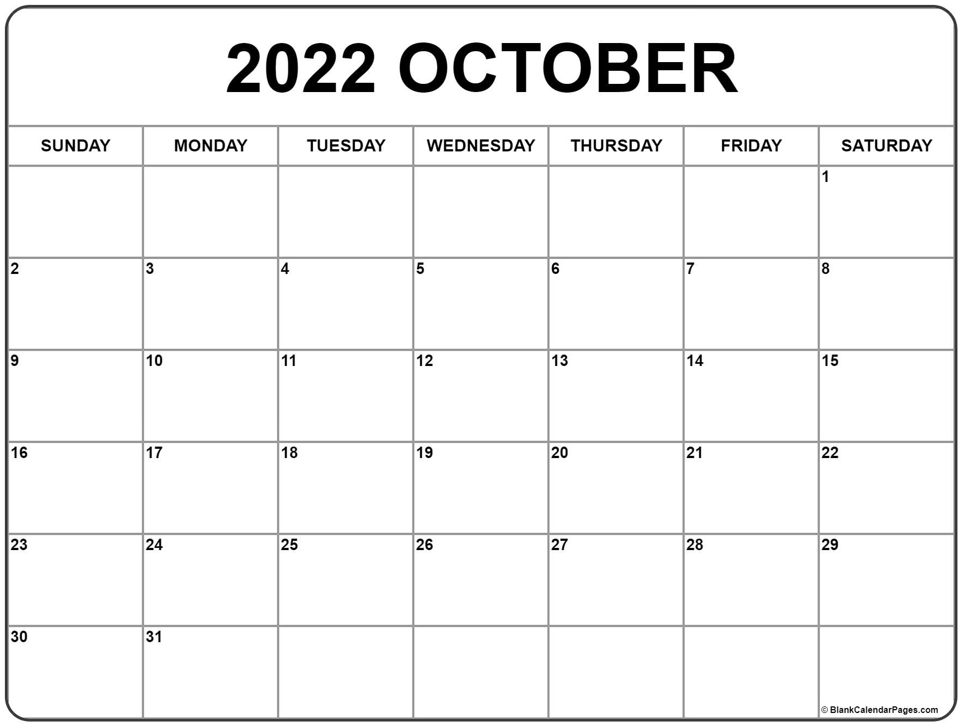

Movie Night

Bake Sale

Carnival or Field Day

End Coin Wars

Color Wars

Talent Show or Karaoke Night

Throwback Thursday

Superhero Day

Twinning Tuesday

Country Pride Day

Sports Day

Dress Like a Teacher

Tacky Tourist Tuesday

Crazy Hat or Sock Day

**United Way Campaign Ends**

Jean Day

Jean Day

Jean Day

Jean Day

**United Way Campaign Begins**

Begin Coin Wars

**SAMPLE**

**SAMPLE**