Tip One: October 2019
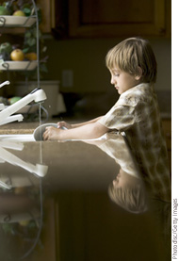

Choose Appropriate Consequences
Your child misbehaves. You send him to his room. Makes sense, right? Wrong. Although simple penalties are okay sometimes, they won’t always make an impression on your youngster. To really help him see the error of his ways, relate the consequence to the bad behavior.
Here’s an example:
Your child often breaks curfew. Fifteen minutes here, fifteen minutes there. He always has an excuse, but it’s never a good one. So you ground him, but he doesn’t seem to care. After all, what’s so bad about hanging out in his room for a while?
Instead, try this: “I’m so worn out from worrying about you when you were late that I couldn’t get my housework done. You’ll need to finish it for me tomorrow while I rest.” Then hand him a list of chores to complete. Teach him that taking up your time will ultimately cost him time.
Brought to you by
Miami Dade County Public Schools
Office of Community Engagement

Tip Two: October 2019

Teach Your Child to Respect Others
Children tune in to just about everything their parents say and do. That’s why parents should put up a united front. If parents are disrespectful to each other, children conclude that this behavior is okay for them too. If they see one parent repeatedly discount the other's feelings and attitudes, they will think they don't have to take the second parent seriously either.
A united front is vital whether parents are married or divorced. It works with two parents at home or just one. It works with biological parents, adoptive parents and others serving in a parental role with children.
Be sure to verbally affirm the other parent and be polite. Don’t team up with your child against the other parent. Parents should support each other’s disciplinary actions. Don’t change the consequences of misbehavior if your child complains. Let your child see parents who sit down and solve problems together. When parents behave respectfully, children will learn to be respectful, too.
brought to you by
Miami Dade County Public Schools
Office of Community Engagement

Tip Three: October 2019
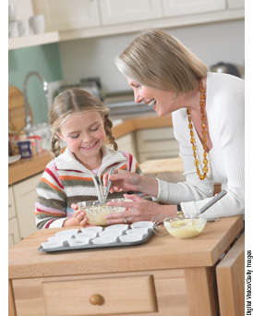

Experiment with
Science at Home
The kitchen is a good place for you and your child to have some fun with science experiments. Here are some simple science activities your child can try:
- Mix oil and water. Watch as they separate.
- Fill a jar with water. Gently drop an egg into the water. It sinks. Now slowly add salt to the water. The egg floats!
- Make a batch of muffins from scratch. Leave the baking soda out of some of the batter. What happens when it is baked? Discuss with your child what happens—and why. Talk about ways to find out if no one knows the answer, such as going to the library or looking online.
brought to you by
Miami Dade County Public Schools
Office of Community Engagement

